Online Payments
for
Subscriptions
and
Camps/Events

Welcome to the 91st Bristol Scout Group! This information sheet explains how we manage and collect payments for termly membership fees (‘subs’) and other costed events such as camps and activity days.
We use a payment system provided by Online Scout Manager (OSM) which allows parents to manage their account and pay online using a secure web site. When your child joins one of the sections of the 91st Bristol Scout Group, you will receive an email from OSM inviting you to set up an account. If you have not received this email within a few weeks of joining, please contact your child's Section Leader.
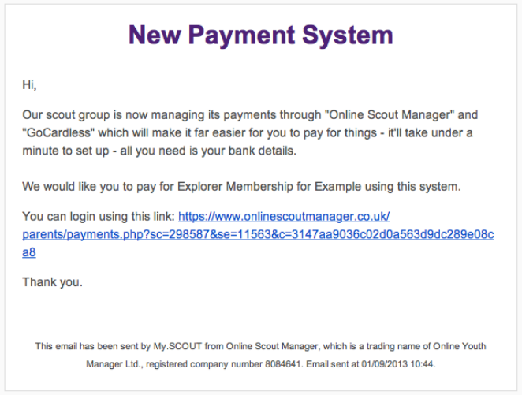
Your account will allow you to create a Direct Debit agreement with the Scout Group so that any fees due are paid automatically. This arrangement is fully protected by the terms of the Direct Debit Guarantee, the full terms of which can be found at https://gocardless.com/direct-debit/guarantee/.
On first logging in to the system you will be presented with the schedules to which you can subscribe. Typically you will see only the Subscriptions schedule initially, and the Camp & Events schedule will show when you child is due to attend their first such event.
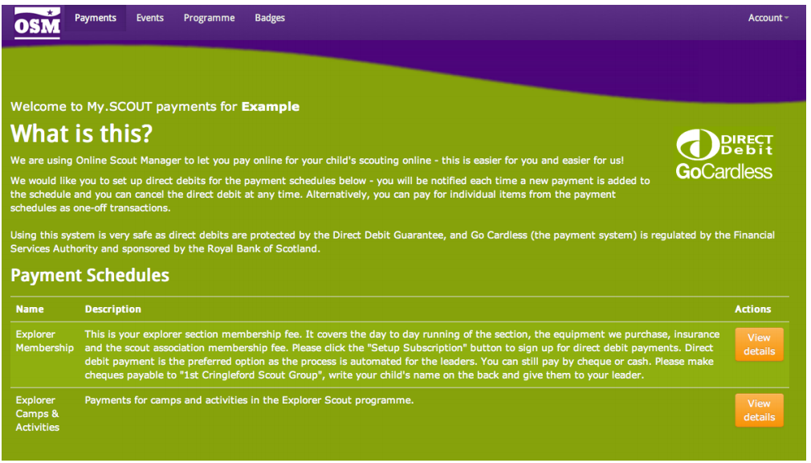
Clicking on ‘View details’ will show you all of the payment due for that schedule. The ‘Setup Subscription’ button allows you to create a Direct Debit for that schedule.
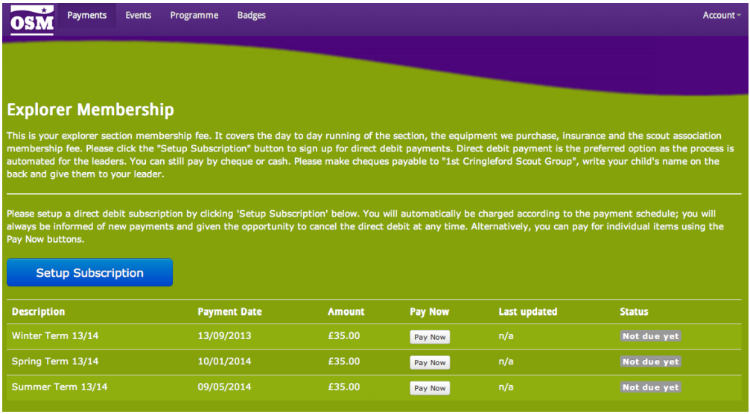
Subs are taken on the date when they become due, usually two weeks after a new term has started, while camp and event fees are taken only when you have confirmed your child will be attending.
You will always be emailed before a payment becomes due. The email will specify the reason for the payment, the amount and the date it will be taken, as well as a link to take you into the OSM site to amend or cancel your payment.
If you do not wish to set up a Direct Debit agreement, the same site will also allow you to make one-off payments using a debit or credit card.
We can still take payment by cash or cheque but this is only as a last resort when for whatever reason it is not possible for parents to use OSM. We have opted to use OSM because it lifts so much of the administrative burden off our section leaders.
If you have any questions at all about anything contained in this document, please email the Group Secretary at secretary@91stbristol.org.uk
.

